**Week 4 Module 5.2 Assignment**

Juan Macias Vasquez

Bellevue University

CSD310-H323 Database Development and Use (2255-DD)

**Adam Bailey**

June 20th, 2025

Module 5.2 Assignment Three SQL Functions

Three SQL Functions with Employee Table

Using Employee Table

Employee (employeeID, name, JobType, Jobrank,MonthlyPay)

('01','Joe Smith', 'Owner', '01', '1000000'),

('02','Jane Smith', 'Co-Owner', '01', '1000000'),

('03','Jay Blue', 'District Manager', '03', '150000'),

('04','Michial Jack', 'Manager', '04', '20000');

**1. COUNT() Function**

Explanation of when used:

Use COUNT() to get the number of records in a table or group.

Usually used to count how many rows meet a certain condition.

Alias:

total_Employees

Screenshot of statement:

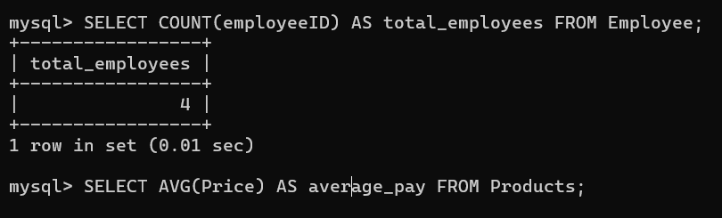

**2. AVG() Function**

Explanation of when used:

Alias:

average_pay

Screenshot of statement:

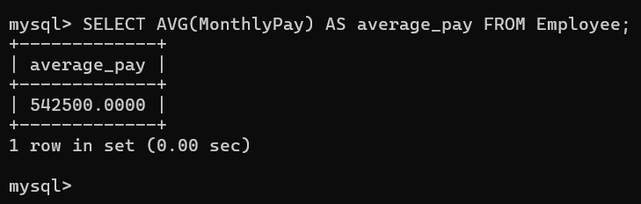

**3. CONCAT() Function**

Explanation of when used:

It can be used for combining things like first and last names in a table to make a full name or in this instance combining a name and the job title to get the full title of an employee.

Alias:

full_title

Screenshot of statement:

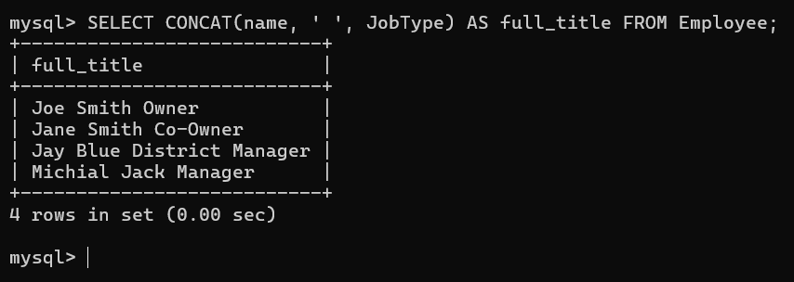

Screen Shot of all three together

